Divyansh Mishra

23BCE5071

**Web Programming**

**Assignment – 11**

Q1

**CODE:**

<!DOCTYPE html>

<html>

<head>

    <title>JavaScript Tasks</title>

    <style>

        #myButton {

            background-color: red;

            color: white;

            padding: 10px;

        }

        #myTextbox {

            background-color: green;

            padding: 5px;

        }

        #keypressCounter {

            margin-top: 10px;

        }

    </style>

</head>

<body>

    <h2>JavaScript Dynamic Tasks</h2>

    <!-- (i) Dynamic 3x3 Table -->

    <div id="tableContainer"></div>

    <br>

    <!-- (ii) Dynamic Button -->

    <div id="buttonContainer"></div>

    <br>

    <!-- (iii) Dynamic Textbox -->

    <div id="textboxContainer"></div>

    <br>

    <!-- (iv) Add li on double click -->

    <input type="text" id="liInput">

    <button id="addLiBtn">Add to List</button>

    <ul id="myList"></ul>

    <br>

    <!-- (v) Keypress Counter -->

    <input type="text" id="keyInput" placeholder="Type here">

    <input type="text" id="keyCountDisplay" readonly>

    <script>

        // (i) Create a 3x3 dynamic table

        let table = document.createElement("table");

        table.border = "1";

        for (let i = 0; i < 3; i++) {

            let row = table.insertRow();

            for (let j = 0; j < 3; j++) {

                let cell = row.insertCell();

                cell.innerHTML = `Row ${i + 1}, Col ${j + 1}`;

            }

        }

        document.getElementById("tableContainer").appendChild(table);

        // (ii) Button with Mouse Over Color Change

        let btn = document.createElement("button");

        btn.id = "myButton";

        btn.textContent = "Hover me!";

        btn.onmouseover = function () {

            btn.style.backgroundColor = "green";

        }

        btn.onmouseout = function () {

            btn.style.backgroundColor = "red";

        }

        document.getElementById("buttonContainer").appendChild(btn);

        // (iii) Textbox Focus & Change

        let textbox = document.createElement("input");

        textbox.type = "text";

        textbox.id = "myTextbox";

        textbox.onfocus = function () {

            textbox.style.backgroundColor = "yellow";

        }

        textbox.onchange = function () {

            alert("Hello! You typed: " + textbox.value);

        }

        document.getElementById("textboxContainer").appendChild(textbox);

        // (iv) Add <li> item to <ul> on double click

        document.getElementById("addLiBtn").ondblclick = function () {

            let text = document.getElementById("liInput").value;

            if (text.trim() !== "") {

                let li = document.createElement("li");

                li.textContent = text;

                document.getElementById("myList").appendChild(li);

                document.getElementById("liInput").value = ""; // clear input

            }

        }

        // (v) Count key presses

        let keyCount = 0;

        document.getElementById("keyInput").onkeydown = function () {

            keyCount++;

            document.getElementById("keyCountDisplay").value = keyCount;

        }

    </script>

</body>

</html>

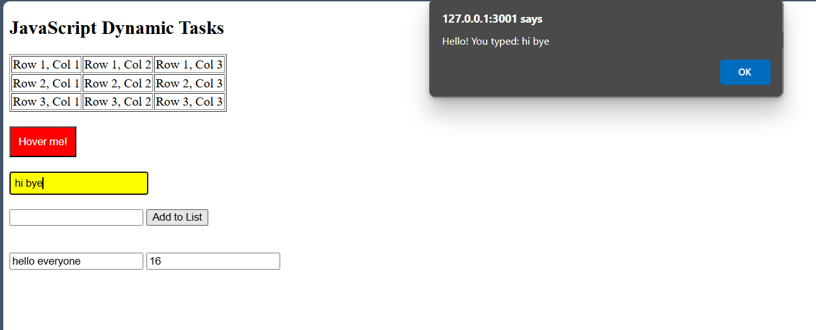

Q2.

Code:

<!DOCTYPE html>

<html>

<head>

    <title>JS Event Listener Tasks</title>

    <style>

        body {

            font-family: Arial;

            padding: 20px;

        }

        .section {

            margin-bottom: 30px;

        }

        button {

            margin: 5px;

            padding: 5px 10px;

        }

        textarea {

            width: 300px;

            height: 100px;

        }

    </style>

</head>

<body>

    <!-- (i) Stopwatch -->

    <div class="section">

        <h3>Stopwatch</h3>

        <div id="stopwatch">00:00:00</div>

        <button id="startBtn">Start</button>

        <button id="stopBtn">Stop</button>

        <button id="resetBtn">Reset</button>

    </div>

    <!-- (ii) DOB Age Calculator -->

    <div class="section">

        <h3>Calculate Age from DOB</h3>

        <input type="date" id="dobInput">

        <p id="ageDisplay"></p>

    </div>

    <!-- (iii) Character Counter -->

    <div class="section">

        <h3>Character Counter</h3>

        <textarea id="myTextarea" placeholder="Start typing..."></textarea>

        <p>Characters typed: <span id="charCount">0</span></p>

    </div>

    <script>

        // (i) Stopwatch

        let timer;

        let seconds = 0;

        function updateStopwatch() {

            let hrs = String(Math.floor(seconds / 3600)).padStart(2, '0');

            let mins = String(Math.floor((seconds % 3600) / 60)).padStart(2, '0');

            let secs = String(seconds % 60).padStart(2, '0');

            document.getElementById("stopwatch").innerText = `${hrs}:${mins}:${secs}`;

        }

        document.getElementById("startBtn").addEventListener("click", () => {

            if (!timer) {

                timer = setInterval(() => {

                    seconds++;

                    updateStopwatch();

                }, 1000);

            }

        });

        document.getElementById("stopBtn").addEventListener("click", () => {

            clearInterval(timer);

            timer = null;

        });

        document.getElementById("resetBtn").addEventListener("click", () => {

            clearInterval(timer);

            timer = null;

            seconds = 0;

            updateStopwatch();

        });

        // (ii) Calculate Age on Mouseover

        document.getElementById("dobInput").addEventListener("mouseover", () => {

            let dob = document.getElementById("dobInput").value;

            if (dob) {

                let birthDate = new Date(dob);

                let today = new Date();

                let age = today.getFullYear() - birthDate.getFullYear();

                let m = today.getMonth() - birthDate.getMonth();

                if (m < 0 || (m === 0 && today.getDate() < birthDate.getDate())) {

                    age--;

                }

                document.getElementById("ageDisplay").innerText = "You are " + age + " years old.";

            }

        });

        // (iii) Character Counter

        document.getElementById("myTextarea").addEventListener("input", () => {

            let count = document.getElementById("myTextarea").value.length;

            document.getElementById("charCount").innerText = count;

        });

    </script>

</body>

</html>

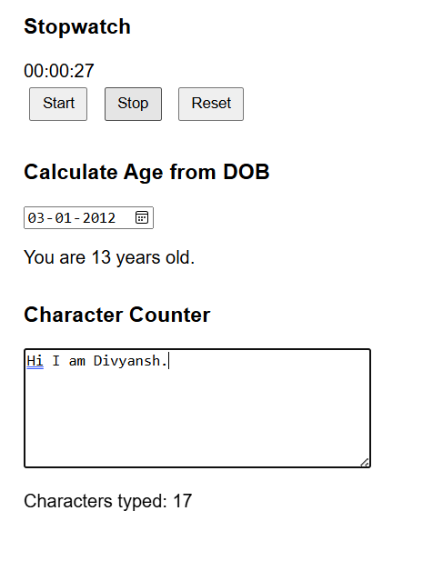

Q3.

Code:

<!DOCTYPE html>

<html>

<head>

  <title>JavaScript Form Validation</title>

  <style>

    .error { color: red; font-size: 14px; }

    .clock {

      float: right;

      border: 1px solid black;

      padding: 5px;

    }

  </style>

  <script>

    // Show Clock

    function updateClock() {

      const clock = document.getElementById("clock");

      const now = new Date();

      clock.innerText = `Time: ${now.toLocaleTimeString()}`;

    }

    setInterval(updateClock, 1000);

    // Print Form

    function printForm() {

      const gender = document.querySelector('input[name="gender"]:checked');

      const country = document.getElementById("country").value;

      const prefs = document.getElementsByName("pref");

      let selectedPrefs = [];

      for (let p of prefs) if (p.checked) selectedPrefs.push(p.value);

      alert(`Gender: ${gender?.value || 'Not selected'}\nCountry: ${country}\nPreferences: ${selectedPrefs.join(", ")}`);

    }

    // Validation

    function validateForm() {

      let f = document.forms["myForm"];

      let name = f["name"].value.trim();

      let address = f["address"].value.trim();

      let zip = f["zip"].value.trim();

      let phone = f["phone"].value.trim();

      let email = f["email"].value.trim();

      let password = f["password"].value;

      let confirm = f["confirm"].value;

      let pan = f["pan"].value.trim();

      if (!name) { alert("Name required"); f["name"].focus(); return false; }

      if (name.length > 15) { alert("Name max 15 chars"); f["name"].focus(); return false; }

      if (!address) { alert("Address required"); f["address"].focus(); return false; }

      if (!zip || isNaN(zip) || zip.length > 6) {

        alert("Invalid Zip"); f["zip"].focus(); return false;

      }

      if (f["country"].value == "select") {

        alert("Select country"); f["country"].focus(); return false;

      }

      if (!f["gender"][0].checked && !f["gender"][1].checked) {

        alert("Select gender"); return false;

      }

      let anyPref = Array.from(document.getElementsByName("pref")).some(p => p.checked);

      if (!anyPref) { alert("Select at least one preference"); return false; }

      if (!phone || isNaN(phone) || phone.length != 10) {

        alert("Invalid phone"); f["phone"].focus(); return false;

      }

      let emailRegex = /^[^\s@]+@[^\s@]+\.[^\s@]+$/;

      if (!emailRegex.test(email)) {

        alert("Invalid email"); f["email"].focus(); return false;

      }

      let passRegex = /^(?=.*[A-Za-z])(?=.*\d)(?=.*[@$!%*?&])[A-Za-z\d@$!%*?&]{8,15}$/;

      if (!passRegex.test(password)) {

        alert("Password must have 8–15 chars with digit, letter, special char"); f["password"].focus(); return false;

      }

      if (password !== confirm) {

        alert("Passwords do not match"); f["confirm"].focus(); return false;

      }

      let panRegex = /^[A-Z]{5}[0-9]{4}[A-Z]{1}$/;

      if (!panRegex.test(pan)) {

        alert("Invalid PAN (e.g., ABCDE1234F)"); f["pan"].focus(); return false;

      }

      alert("Form submitted successfully!");

      return true;

    }

  </script>

</head>

<body onload="updateClock()">

  <form name="myForm" onsubmit="return validateForm()">

    <div class="clock" id="clock"></div>

    <h2>Test JavaScript Form Validataion</h2>

    Name* <input type="text" name="name"><br><br>

    Address* <textarea name="address"></textarea><br><br>

    Zip Code* <input type="text" name="zip"><br><br>

    Country*

    <select name="country" id="country">

      <option value="select">Please select...</option>

      <option value="India">India</option>

      <option value="USA">USA</option>

    </select><br><br>

    Gender*

    <input type="radio" name="gender" value="Male"> Male

    <input type="radio" name="gender" value="Female"> Female<br><br>

    Preferences*

    <input type="checkbox" name="pref" value="Red"> Red

    <input type="checkbox" name="pref" value="Green"> Green

    <input type="checkbox" name="pref" value="Blue"> Blue<br><br>

    Phone* <input type="text" name="phone"><br><br>

    Email* <input type="text" name="email"><br><br>

    Password* <input type="password" name="password"><br><br>

    Verify Password* <input type="password" name="confirm"><br><br>

    PAN No: <input type="text" name="pan"><br><br>

    <input type="submit" value="SEND">

    <input type="reset" value="CLEAR">

    <button type="button" onclick="printForm()">Print Info</button>

  </form>

</body>

</html>

